

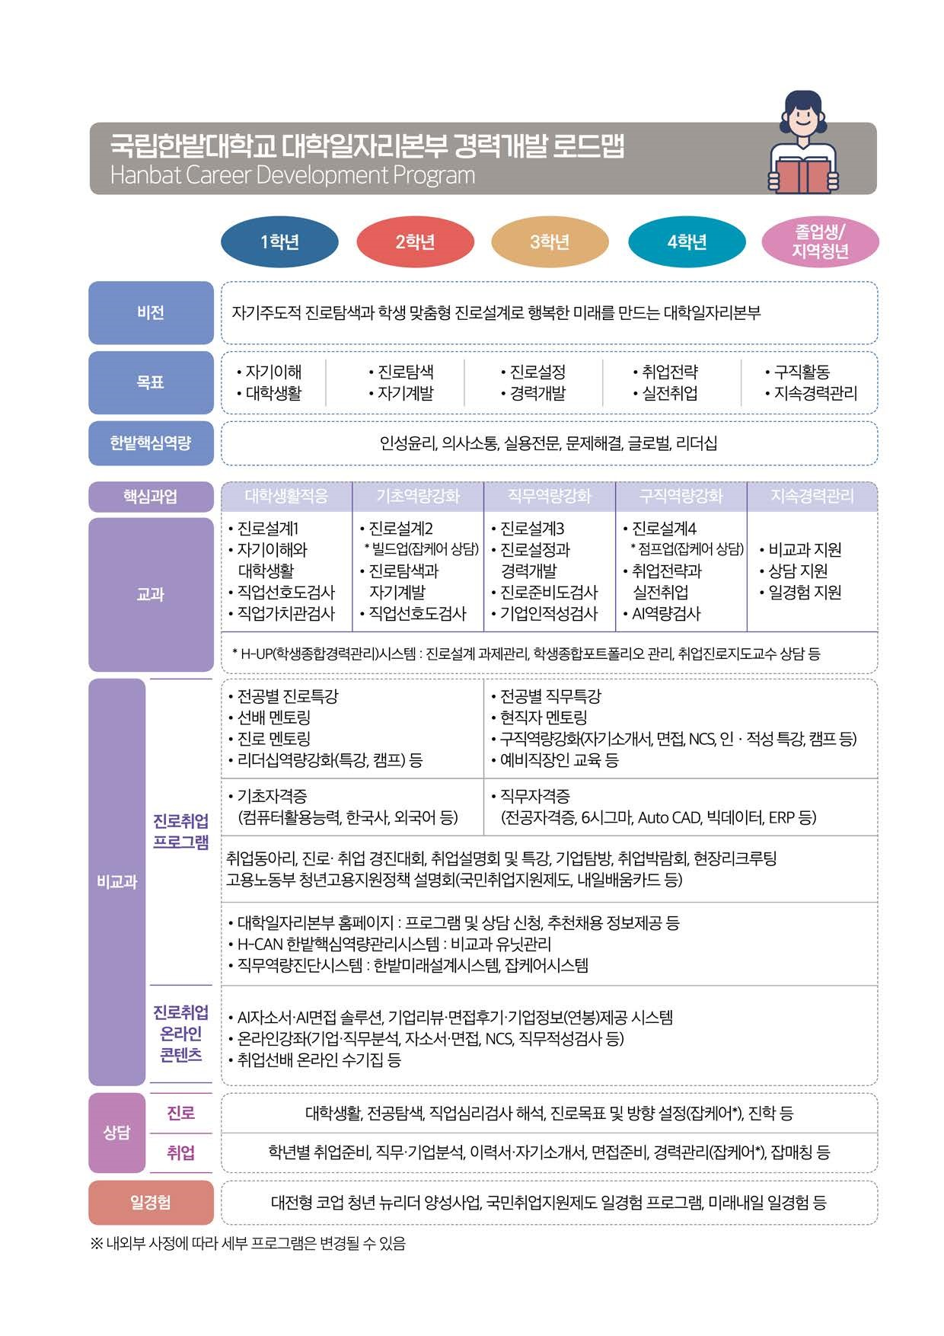

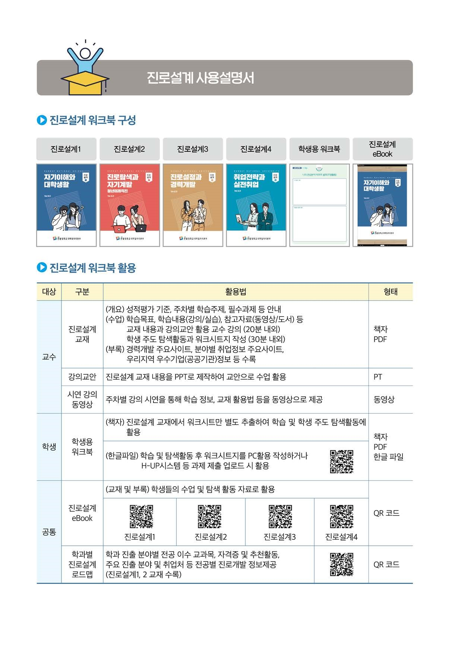

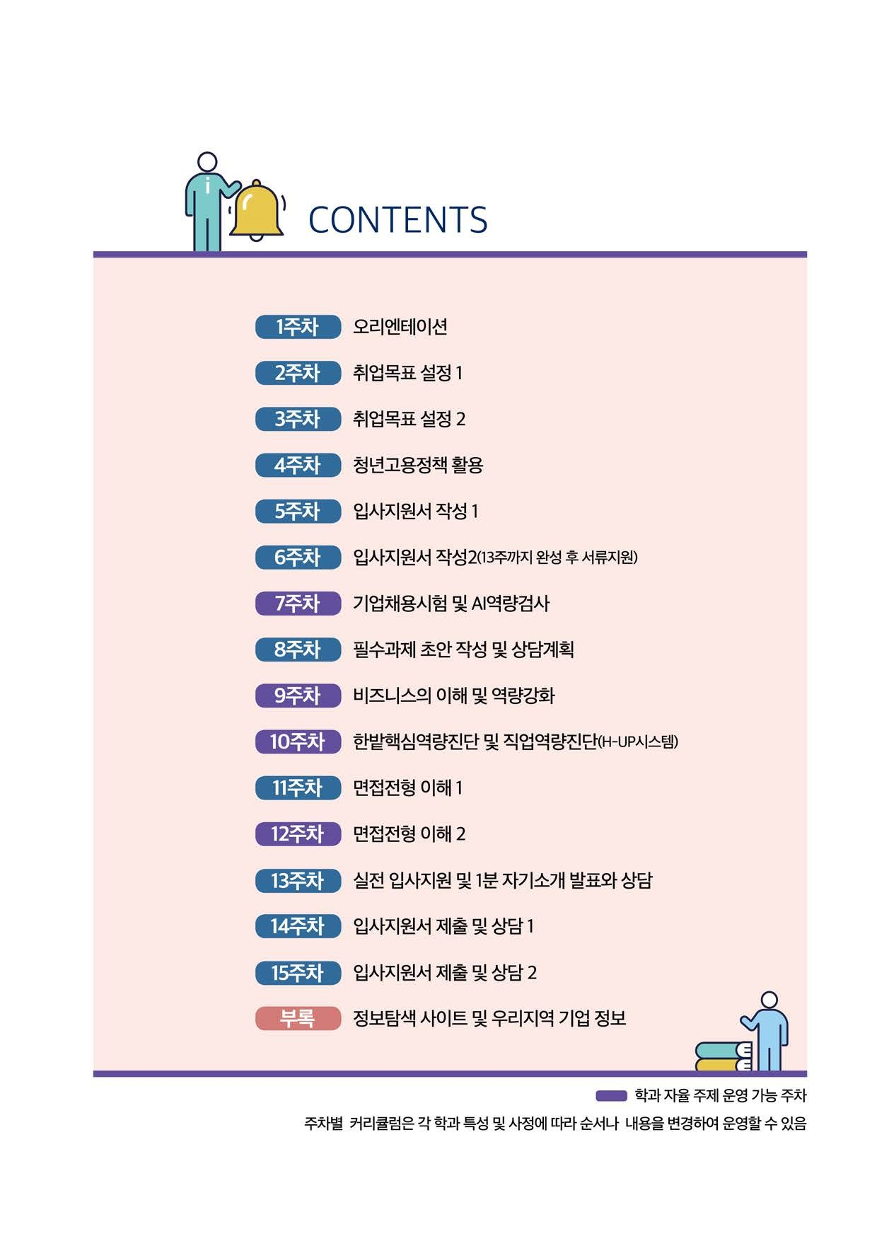

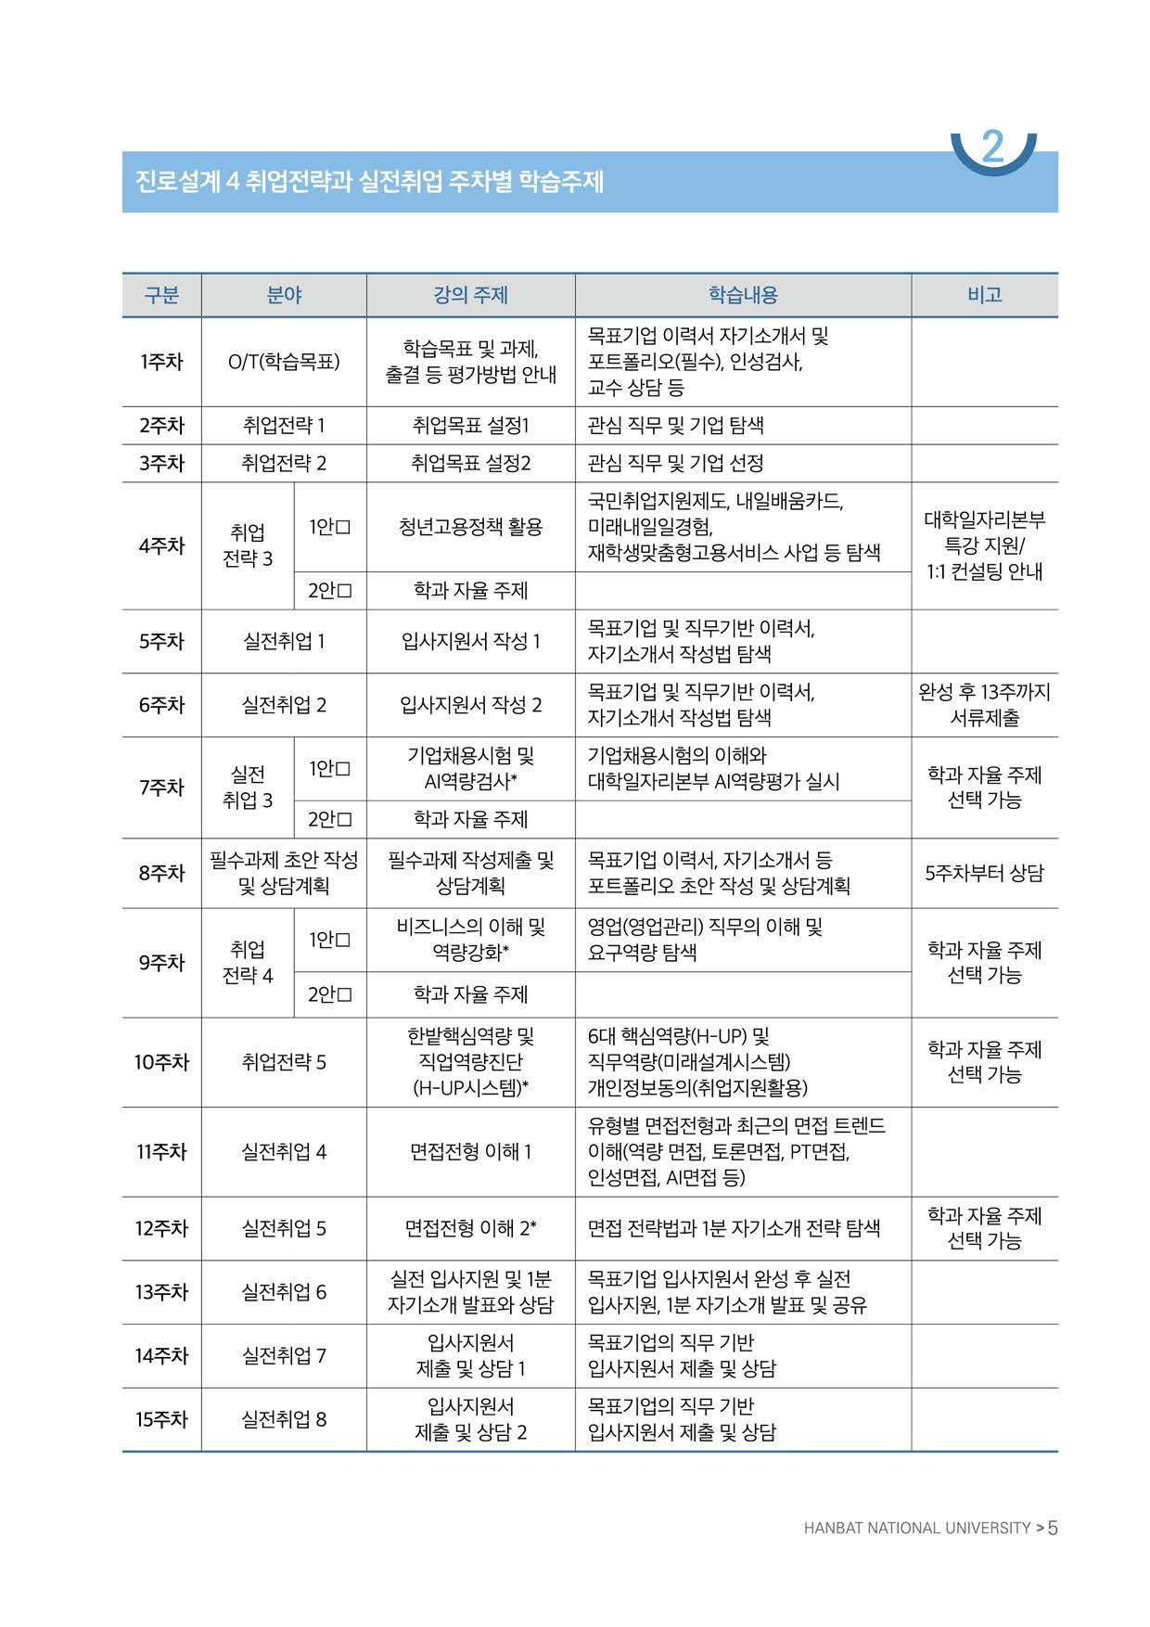

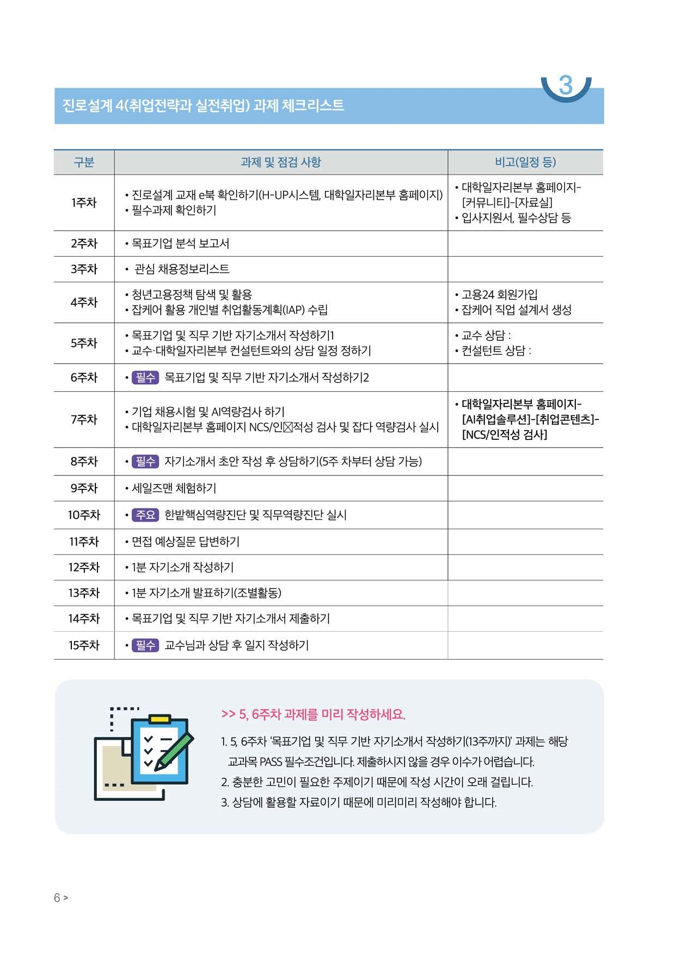

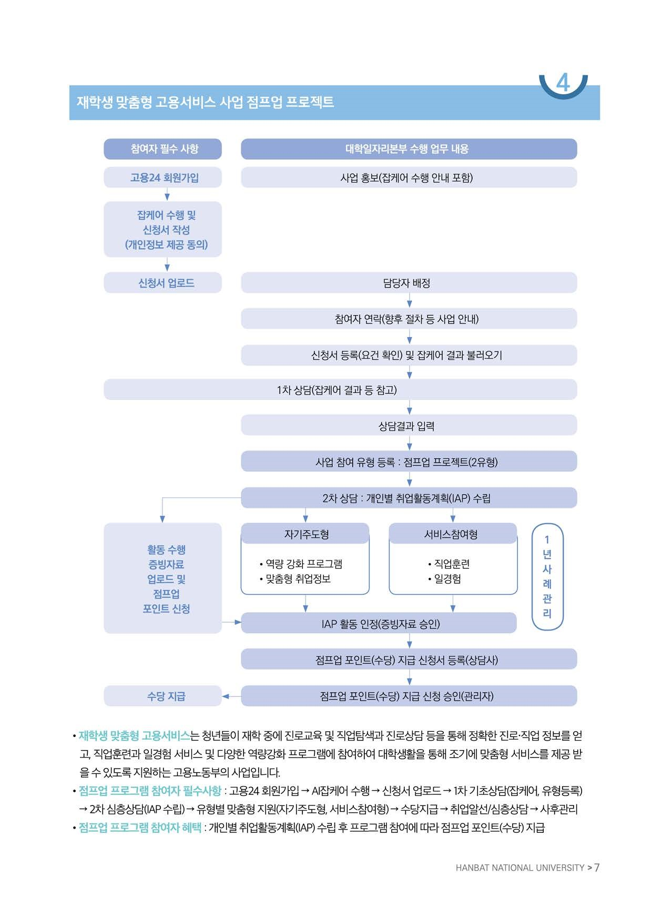

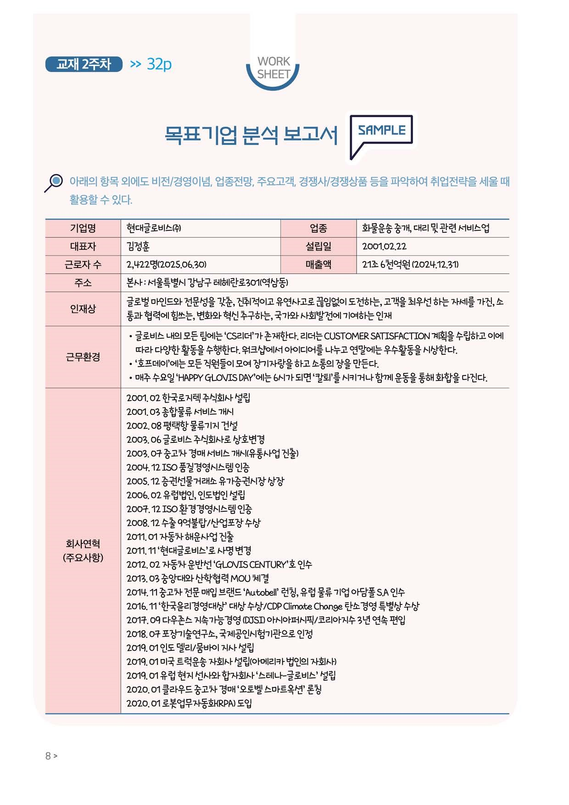

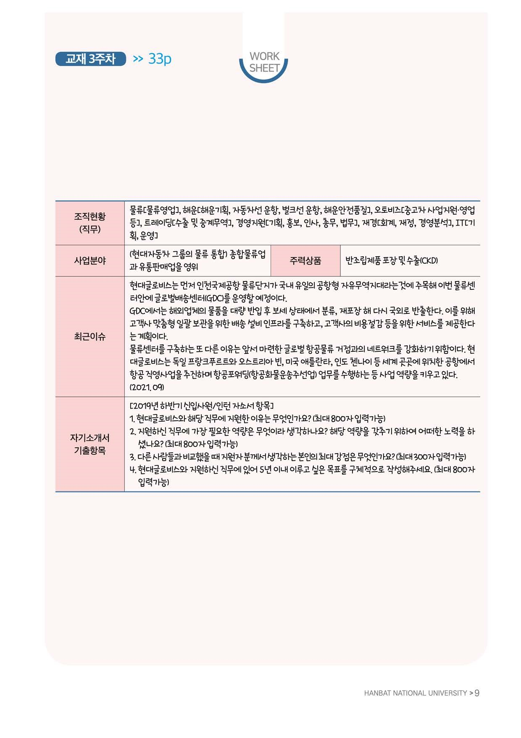

✓
✓

✓
✓
✓
✓
✓

✓
✓
✓

(20 년 월 예상)

행정·사무원
(0,000만 원)
(중·소기업, 중견, 대기업, 공공기관, 외국계 등)

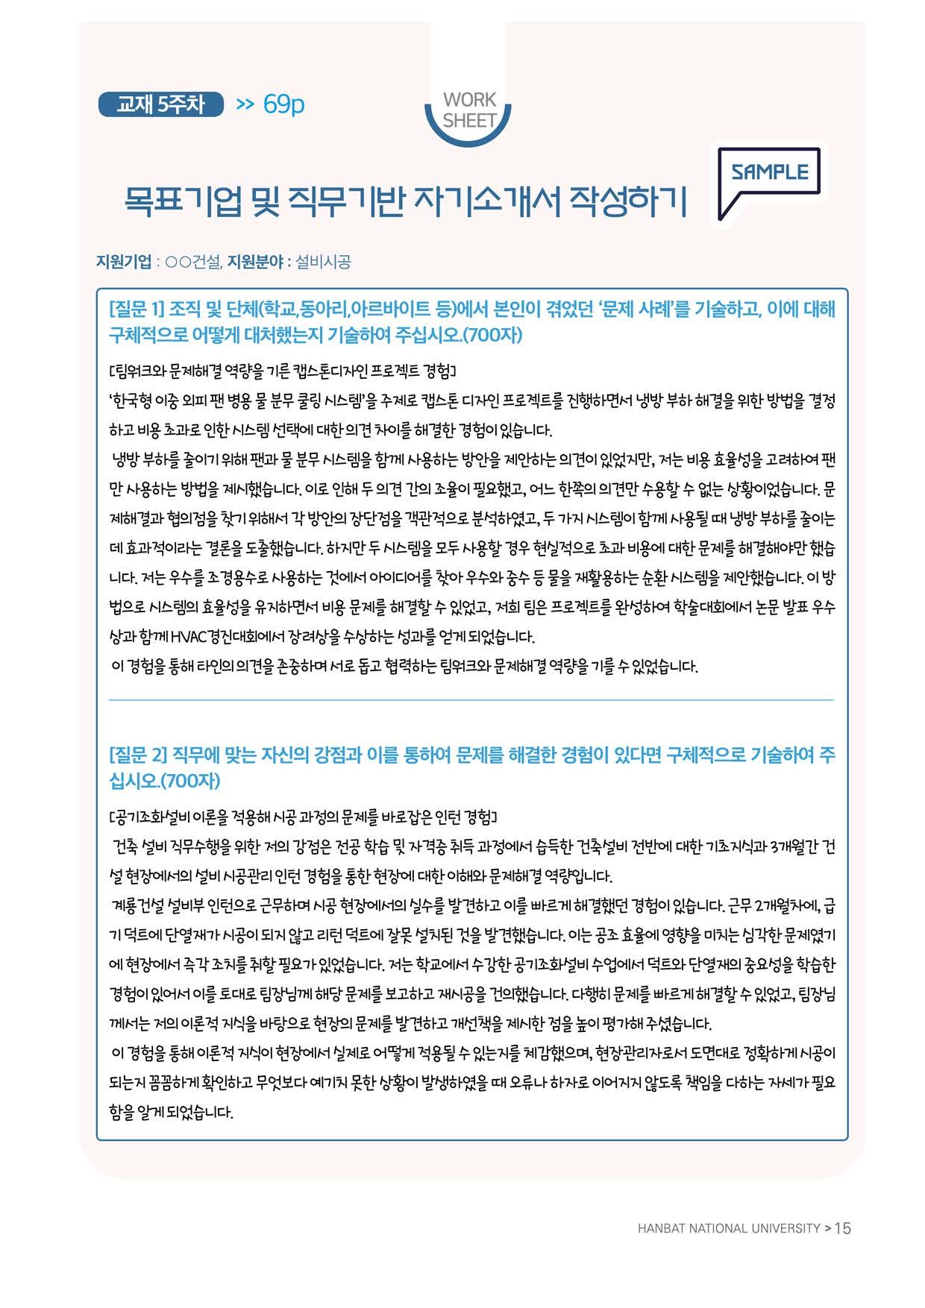

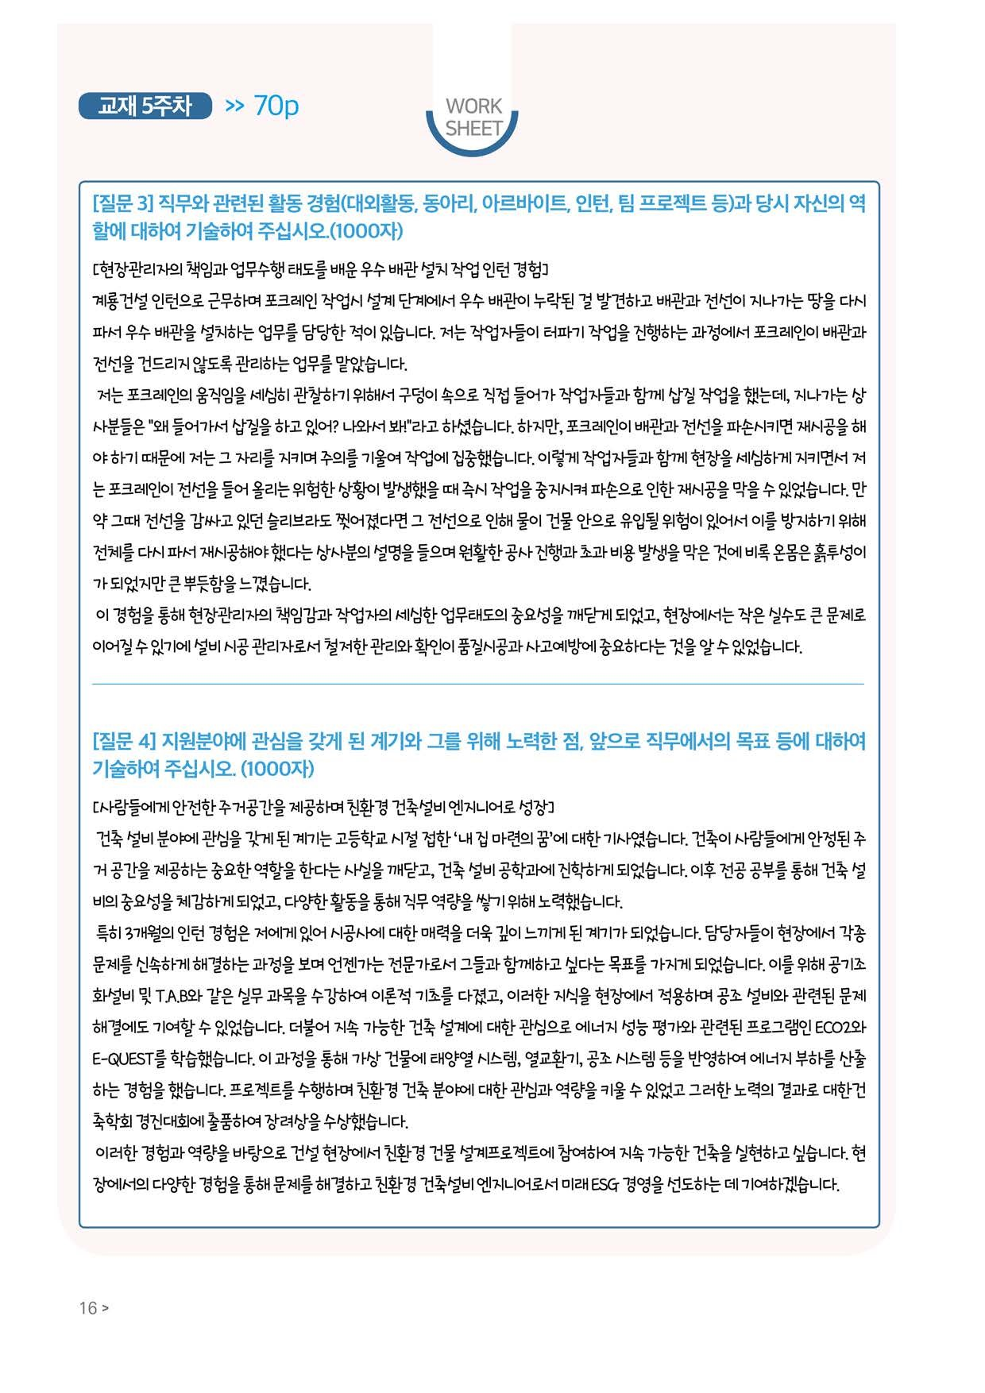

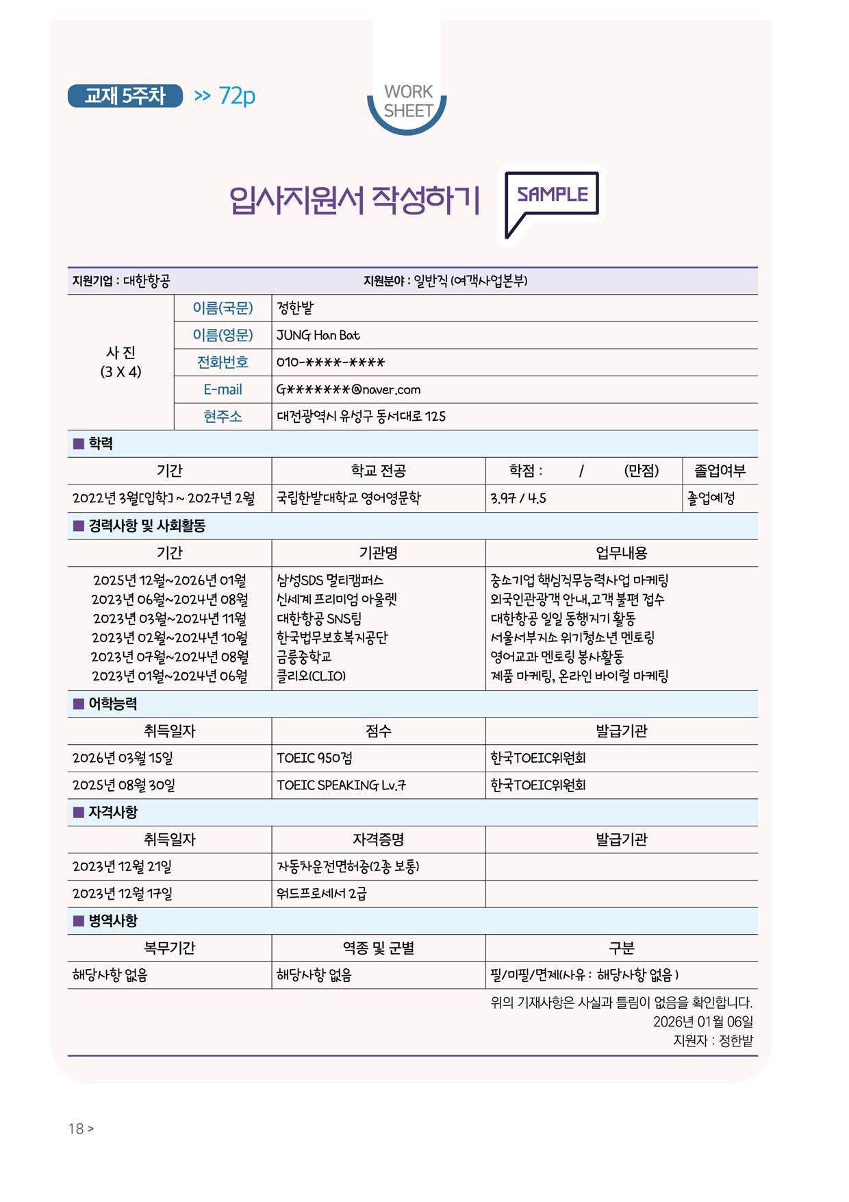

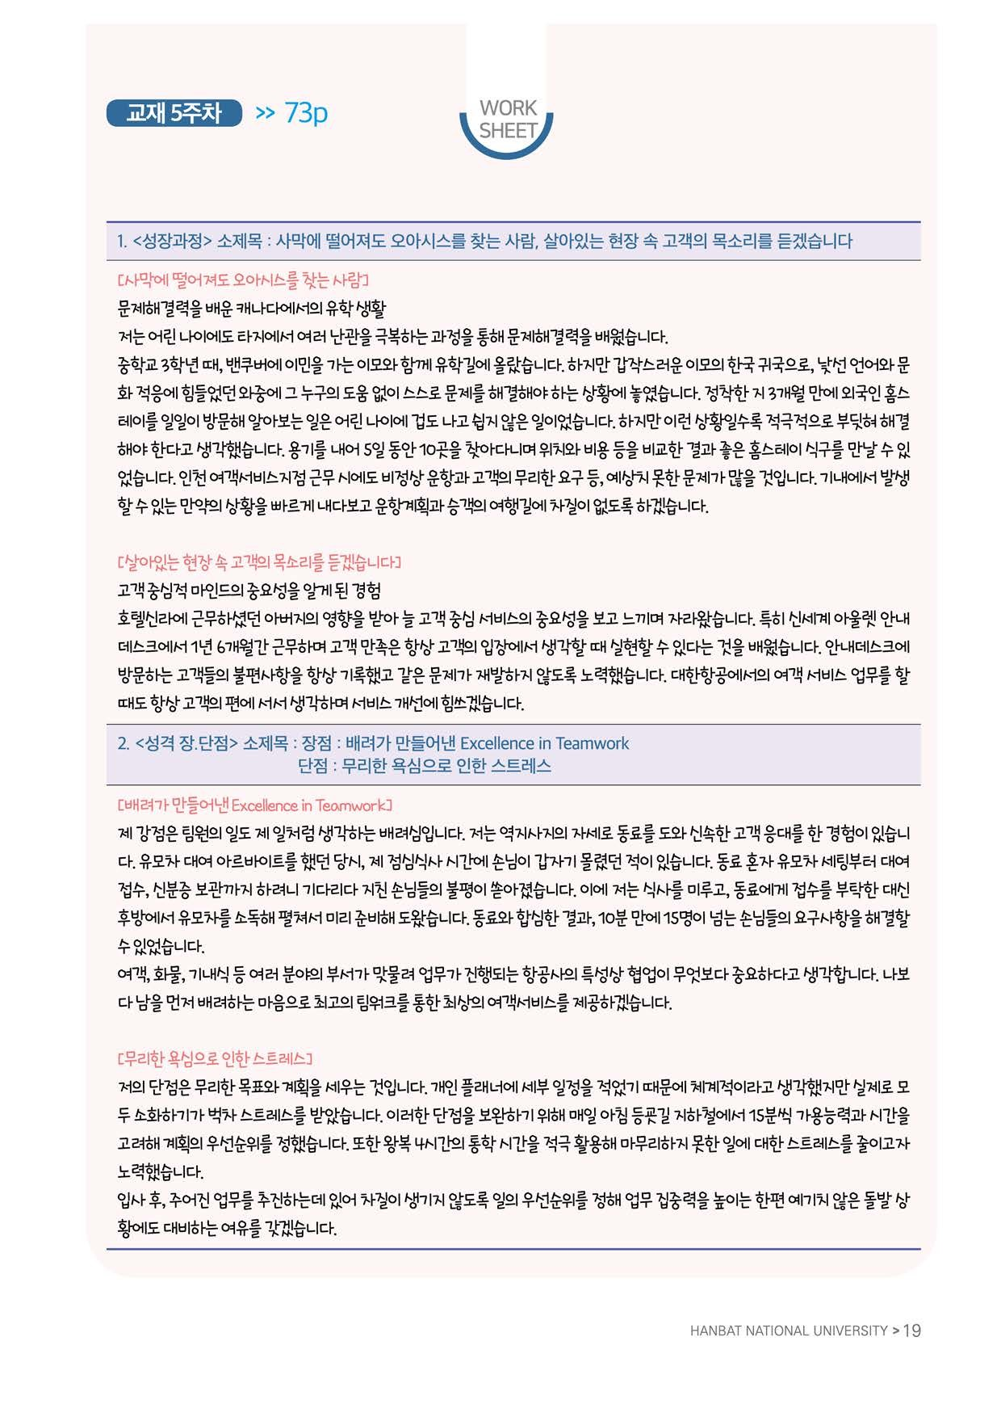

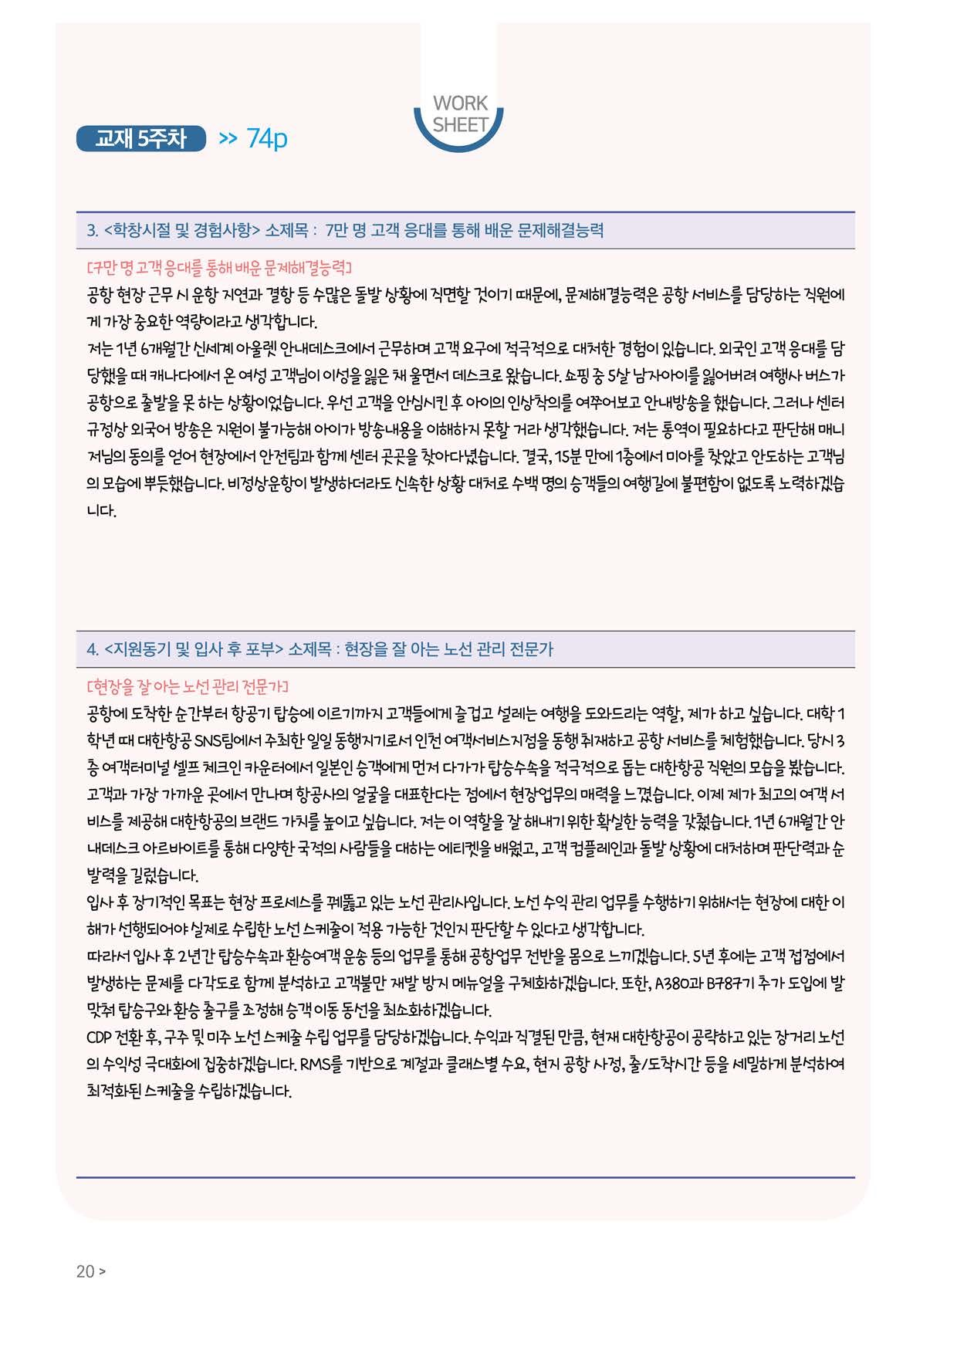

년 월 일






















































































































